# Digital Marketing for a Startup Begins with Your Company Profile—Here’s Why

[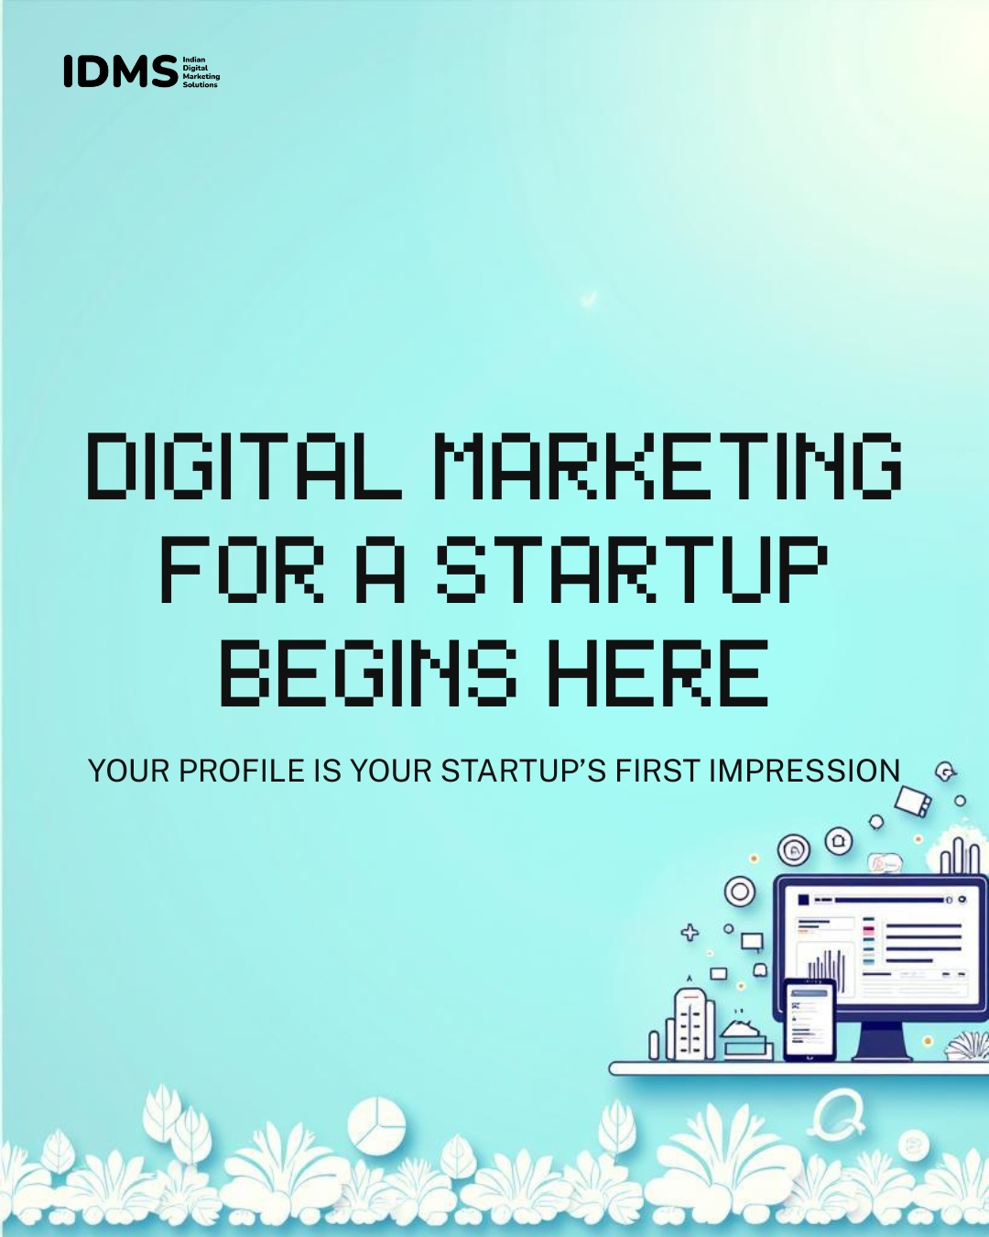](https://www.idms.co.in/)

## Introduction:

Starting a new business is exciting—but also overwhelming. As a startup, you're likely focused on building your product, finding customers, and managing finances. But there’s one simple thing that often gets overlooked—your **company profile**. And believe it or not, it plays a big role in your **digital marketing** success.

In today’s online world, people don’t just “find” your business—they Google it. They check your website, social media, and reviews before making a decision. This is where a strong company profile becomes your first chance to make a good impression. It's the foundation for all your marketing efforts, especially if you're planning to work with **digital marketing companies** or invest in **digital marketing services**.

For any business, but especially when doing [**digital marketing for a startup**](https://www.idms.co.in/), your profile isn’t just a formal document. It tells the world who you are, what you stand for, and why someone should trust you. It’s your story—made for the internet.

In this article, we’ll explain why your company profile is more than just “About Us.” It’s your first step toward growth.

## What Is a Company Profile—and What Makes It Startup-Ready?

A **company profile** is a short but powerful introduction to your business. It tells people who you are, what you do, why you do it, and what makes you different. Think of it as your startup’s digital handshake—it helps people understand your purpose at a glance.

But here's the thing: not all company profiles are created equal—especially when you're doing **digital marketing for a startup**.

A **startup-ready company profile** is one that’s built for speed, clarity, and connection. It's not just formal or boring text. It speaks directly to your audience—whether it's customers, investors, or even **digital marketing companies** you plan to work with.

Here’s what makes a company profile startup-ready in 2025:

#### **1. Clear and Concise Messaging**

Avoid buzzwords. Be direct. Explain what your startup does in simple terms that even a non-expert can understand.

#### **2. Highlight Your Unique Value**

What problem are you solving? Why should people care? This is the heart of your **digital marketing strategy**.

#### **3. Mobile and SEO Friendly**

Your company profile might appear on your website, social media bios, and Google Business listing. Use keywords like [**digital marketing services**](http://www.idms.co.in), your industry, and your location for better visibility.

#### **4. Designed for Sharing**

A well-designed, modern profile with visuals, links, and even a short video can boost engagement and shares online.

#### **5. Tells a Human Story**

People connect with people, not just products. Add a touch of your founder journey, values, or mission. This builds trust—especially helpful when you're just starting out.

Whether you’re bootstrapping or planning to scale fast, your company profile isn’t just an intro—it’s your first **marketing asset**. And in a competitive digital world, that matters more than ever.

## First Impressions Count: Your Profile as a Digital Trust Anchor

[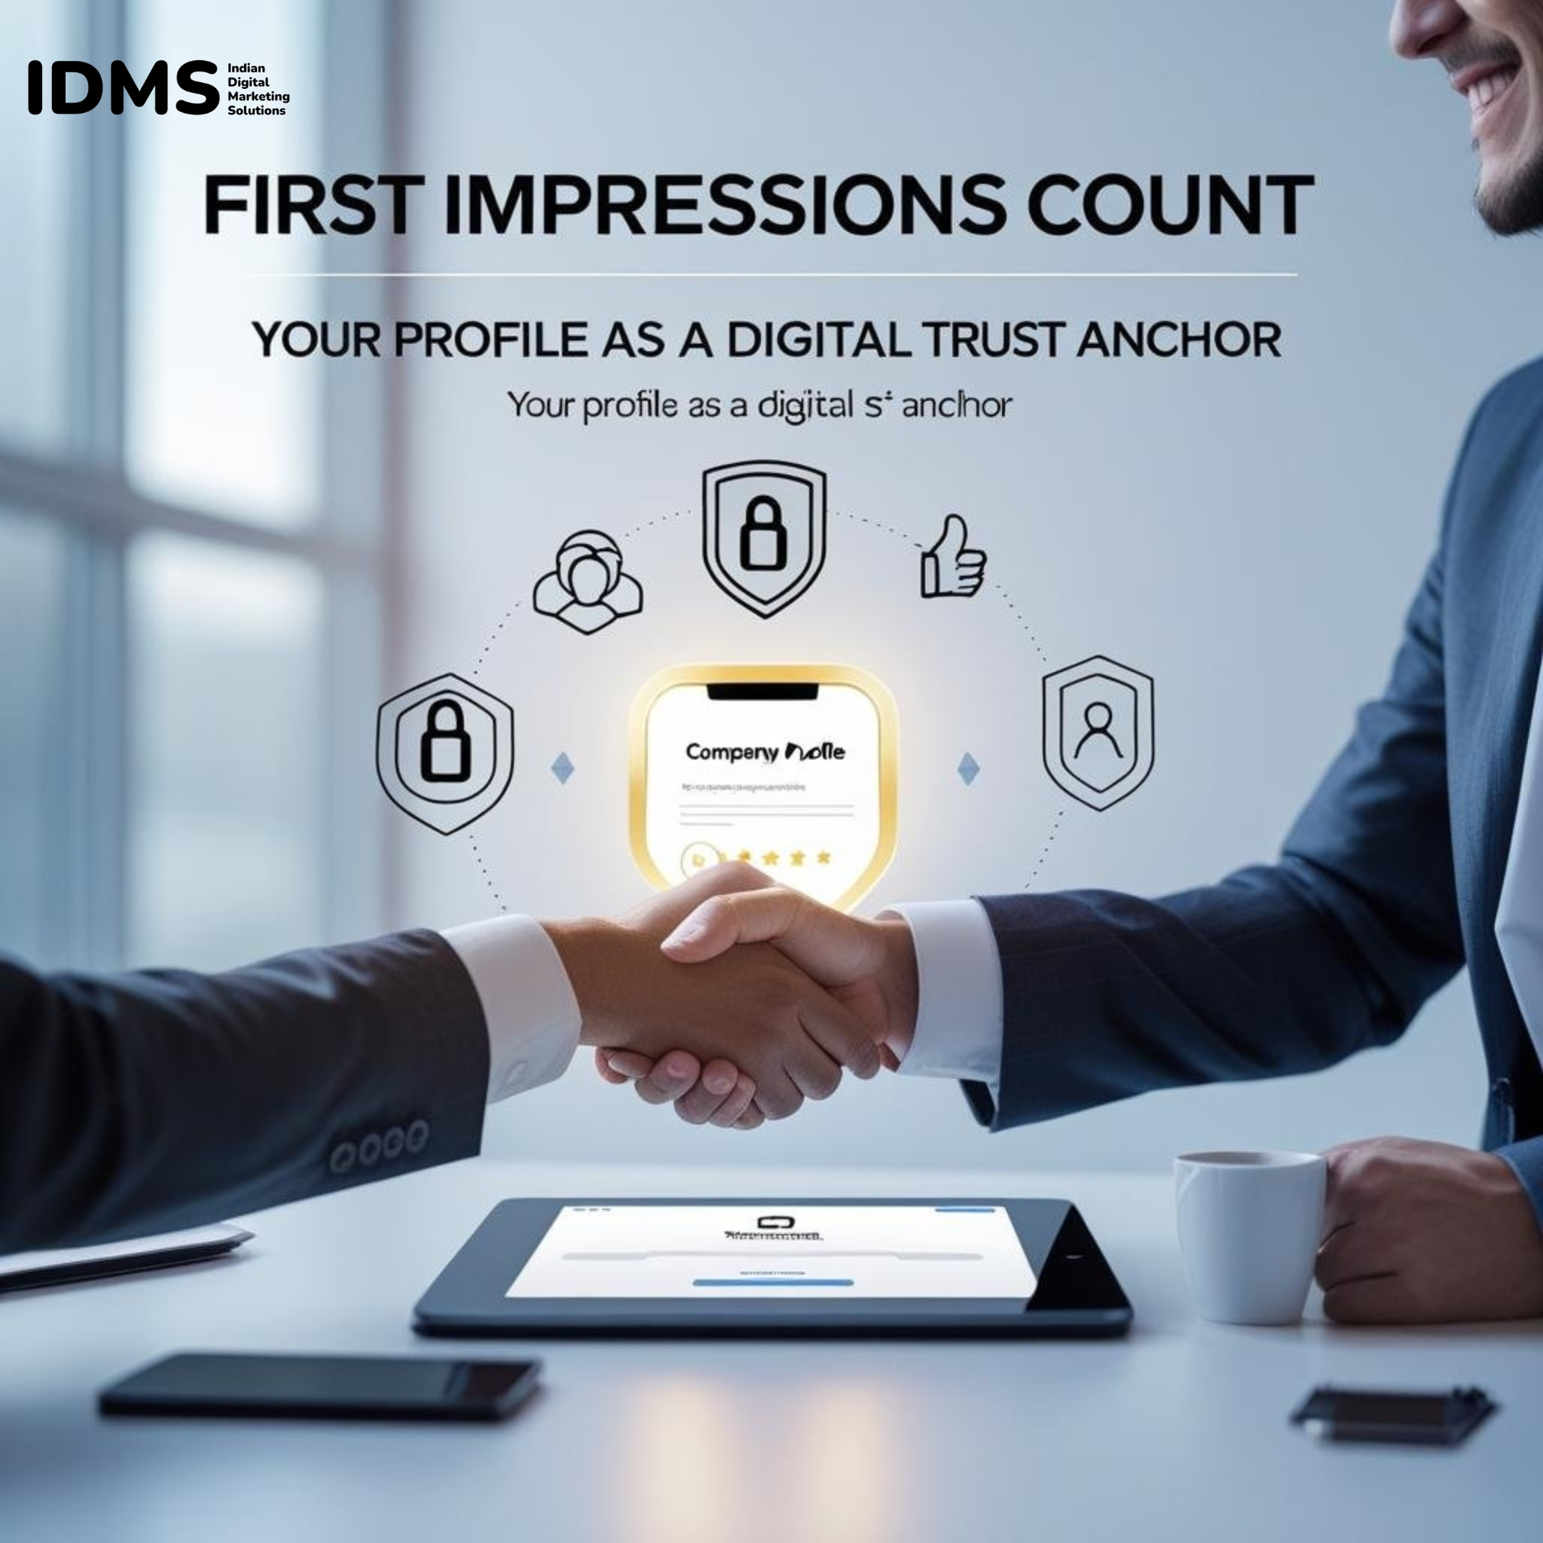](https://www.idms.co.in/)

In the world of **digital marketing for a startup**, first impressions don’t happen in person—they happen online.

Before a customer buys from you, before an investor emails you back, and before a partner agrees to a meeting, they’re likely doing one thing first: **Googling your business**. And what do they see? Often, it’s your company profile.

This is where your profile becomes a **digital trust anchor**.

A well-written, professional profile shows that you’re serious, credible, and ready for business. It gives visitors the confidence to explore your product or service further—and that’s a huge win, especially in those early stages when you're still building brand awareness.

#### **Why It Matters for Startups:**

* **People trust clarity** – A clear company profile reduces confusion and builds credibility.
* **Digital marketing companies** often use your profile as a reference point when creating campaigns or content.
* **Investors and partners** use it to quickly understand your mission, market, and value proposition.
* **Customers use it** to decide if you're a brand they want to engage with or trust with their money.

Just like a resume helps you get a job, your startup’s company profile helps you earn trust online. It's not just about who you are—it's about showing others that you’re worth their time, attention, and investment.

## SEO Starts Here: Optimizing Your Company Profile for Search Visibility

When people search for your business—or even the kind of services you offer—you want to show up. That’s where [**SEO (Search Engine Optimization)**](https://www.idms.co.in/) comes in. And believe it or not, it all starts with your **company profile**.

Whether it’s on your website, Google Business, LinkedIn, or directories, your profile is often one of the **first places search engines crawl** to understand what your startup is all about. So if you're investing in **digital marketing services** or working with **digital marketing companies**, optimizing your profile is a smart first step.

#### **How to Make Your Company Profile SEO-Ready:**

##### **1. Use the Right Keywords (Naturally)**

Include keywords people are actually searching for—like:

* *digital marketing for a startup*
* *affordable tech solutions for small businesses*
* *AI-based healthcare platform* (or whatever fits your niche)

Place these keywords in:

* Your company description
* Tagline or mission statement
* Services or product section

But remember: write for humans first, Google second.

##### **2. Add Location Details (If Relevant)**

If you're serving a local market, mention your city or region. For example:  
 “Based in Bangalore, we offer digital marketing services for early-stage tech startups.”

This boosts your visibility in **local search results**, especially on Google Maps or local listings.

##### **3. Link Smartly**

Include one or two relevant links—such as to your homepage, service pages, or portfolio. This helps Google understand your website structure and gives users easy next steps.

##### **4. Use a Clear Structure**

Break your profile into sections:

* Who we are
* What we do
* Who we help
* Why choose us

Search engines love well-organized content, and so do readers.

##### **5. Keep It Updated**

Outdated profiles can hurt trust and SEO. Refresh your content regularly—especially when your services, team, or vision evolve.

**Pro Tip:** If you're working with a [**digital marketing company**](https://www.idms.co.in/), ask them to audit your profile from an SEO perspective. Small tweaks here can lead to big visibility gains.

Your profile doesn’t need to be stuffed with keywords—it just needs to reflect what your audience is searching for. When done right, it's one of the easiest ways to **boost your startup's discoverability** online.

## Consistency Is Key: Branding Across Platforms

Your startup’s message shouldn’t change every time someone finds you on a different platform. Whether a potential customer discovers you on Google, LinkedIn, Instagram, or your website, they should see the same brand identity, tone, and values.

This is where **branding consistency** plays a powerful role—and your **company profile** is the foundation.

If you’re investing in **digital marketing services** or working with **digital marketing companies**, one of the first things they'll focus on is brand alignment across channels. Why? Because inconsistent messaging can confuse your audience, dilute trust, and weaken your online presence.

#### **Why Consistency Matters in Digital Marketing for a Startup**

1. **Builds Brand Recognition** When your visuals, messaging, and tone are consistent, people start to recognize your brand more quickly. This helps you stand out in a crowded digital space.
2. **Improves Trust and Credibility** A professional-looking, consistent profile across platforms shows you're serious and reliable—crucial for early-stage startups still building their reputation.
3. **Supports SEO & Social Growth** Consistent keywords and messaging across channels reinforce your identity to search engines and improve discoverability on platforms like LinkedIn, Instagram, and Google.
4. **Smooth Customer Experience** If someone reads your company profile on LinkedIn and then visits your website, they should feel like they’re in the same place—same tone, same values, same promise.

#### **What to Keep Consistent:**

* **Company Name & Tagline**
* **Mission and Vision**
* **Brand Voice & Writing Style**
* **Logo, Color Scheme & Fonts**
* **Key Services or Product Descriptions**
* **Call-to-Actions (CTAs)**

When all your digital touchpoints speak the same language, you create a strong, unified presence—one that makes people remember and trust you. And in the early stages of **digital marketing for a startup**, that’s gold

## Case Study Spotlight: How a Strong Profile Helped This Startup Scale

To see the real impact of a strong company profile, let’s look at a startup that used this simple asset to unlock major growth.

**Startup: GrowLocal – A Hyperlocal Marketing Tech Startup**

**Industry:** SaaS  
 **Stage:** Pre-seed  
 **Goal:** Attract early users and gain investor attention  
 **Challenge:** Low online visibility, inconsistent branding, no formal company profile

**What They Did:**

GrowLocal started with basic [**digital marketing for a startup**](http://www.idms.co.in)—a landing page and a few social media accounts. But they weren’t seeing traction. A digital marketing agency advised them to begin with the basics: a **professional, SEO-optimized company profile**.

Here's how they turned it around:

* They created a clear, concise company overview with targeted keywords like *hyperlocal marketing tools for small businesses* and *AI-powered local marketing*.
* Added their **mission, product benefits, and founder story** to create emotional connection.
* Ensured this updated profile was consistent across their **website, LinkedIn, AngelList, and startup directories**.
* Included internal links to their product demo and contact page for better engagement and SEO.

**The Results:**

Within 60 days, GrowLocal saw:

* **62% increase in organic website visits** (mostly from branded and service-related keywords)
* **Better investor engagement**—two VC firms mentioned their company profile was "clear and compelling"
* **Stronger partner outreach** from local agencies looking to collaborate
* **Consistent branding** that boosted their credibility across all platforms

**Key Takeaway:**

Even before they ran paid ads or hired a full-time marketer, GrowLocal’s **well-crafted company profile** became the launchpad for growth. It gave them the clarity, trust, and visibility they needed to scale early.

Whether you’re a SaaS founder or an eCommerce brand, this proves that digital success doesn’t always start with ads—it starts with a story well told.

## Beyond About Us: Turning Your Profile Into a Marketing Tool

Too often, startups treat their **company profile** like a checkbox—something to slap on an "About Us" page and forget. But in the world of **digital marketing for a startup**, your profile can be **so much more** than a bland summary.

When done right, it becomes a **powerful marketing tool** that drives trust, engagement, and conversions.

### Here's How to Transform Your Company Profile into a Growth Engine:

#### **1. Speak to Your Ideal Customer**

Your profile shouldn't just say what you do—it should explain **how you help**. Use language that resonates with your audience’s pain points. For example:

Instead of:  
 “We offer digital marketing services to startups.”  
 Try:  
 “We help startups grow fast with cost-effective digital marketing strategies tailored to your goals.”

This immediately tells the reader why you matter.

#### **2. Use Strategic Keywords (Naturally)**

Keywords like **digital marketing companies**, **digital marketing services**, or **growth marketing for startups** help your profile rank in search engines. But don’t stuff them—make them flow naturally in your messaging.

Example:

“As one of the emerging **digital marketing companies** focused on startups, we offer services that help early-stage founders build visibility from day one.”

#### **3. Add CTAs (Call-to-Actions)**

Turn your profile into a lead magnet. Add direct prompts like:

* “Book a free consultation”
* “Download our pitch deck”
* “Explore our latest case studies”

These CTAs encourage the reader to take the next step, turning interest into action.

#### **4. Make It Visually Appealing**

Break long text into sections, add icons, images, or even a short intro video. Your company profile should **feel modern and easy to scan**—especially on mobile.

#### **5. Embed Social Proof**

If you have testimonials, media mentions, awards, or notable partners, weave that into your profile. These signals build instant trust with both customers and investors.

#### **6. Link to Key Pages**

Guide readers deeper into your digital world by linking your:

* Homepage
* Services page
* Portfolio or case study section
* Contact or lead form

This not only boosts SEO but also increases time spent on site—a great ranking factor.

**Remember:**

Your company profile is often the **first marketing message** someone reads about your business. So don’t just tell people what you do—**show them why it matters and what to do next**.

It’s your chance to market without selling, and connect without overwhelming.

## Mistakes to Avoid When Writing Your Startup Profile

Writing your **startup’s company profile** may seem simple—but getting it wrong can cost you credibility, visibility, and growth opportunities. Especially when you’re investing in **digital marketing for a startup**, your profile should support—not sabotage—your online presence.

To help you get it right from the start, here are the most common mistakes startups make—and how to avoid them:

#### **1. Being Too Vague or Generic**

Saying things like “We provide innovative solutions” sounds nice… but what does it actually mean?

**Fix it:** Be specific. Tell people exactly what you do, who you help, and what results they can expect.

Example: Instead of “We offer digital marketing services,” try  
 “We help early-stage startups grow with tailored SEO, paid ads, and content marketing strategies.”

#### **2. Keyword Stuffing for SEO**

Yes, using keywords like [**digital marketing services**](https://www.idms.co.in/) or **digital marketing companies** is important. But if you force them into every sentence, your profile will sound robotic—and turn readers off.

**Fix it:** Use keywords naturally, and focus on making your message clear and human-friendly.

#### **3. Forgetting the "Why"**

Most profiles say what the company does, but skip why it exists. Without a clear purpose or mission, it’s hard to stand out or connect emotionally.

**Fix it:** Include your "why"—your mission, your story, your passion. This builds trust and relatability.

**4. Writing a One-Size-Fits-All Profile**

Copying the same profile across every platform without tweaking it for the audience or format is a missed opportunity.

**Fix it:** Customize your profile for different platforms (LinkedIn, website, directories) while keeping the core message consistent.

#### **5. Ignoring Design and Readability**

A wall of text is hard to read and uninviting. Especially on mobile devices.

**Fix it:** Use headers, bullet points, short paragraphs, and visuals to make your profile easier to skim and more engaging.

**6. Leaving It Outdated**

If your profile still says "Coming soon" or lists old services, it sends a bad signal to customers and search engines alike.

**Fix it:** Review and refresh your company profile regularly—especially when your startup grows, pivots, or expands its offerings.

#### **7. No Call-to-Action (CTA)**

Many startups forget to tell people what to do next—visit the site, schedule a demo, or connect on LinkedIn.

**Fix it:** Add a clear CTA at the end of your profile. Turn interest into engagement.

## Conclusion

Your startup’s company profile is **not just a formality**—it’s a strategic asset. Avoiding these common mistakes ensures your profile supports your **digital marketing efforts**, builds trust, and helps your audience say, “Yes, this is the brand I’ve been looking for.”

### **Author Bio**

**Moinul Hoque Choudhury** is a growth-focused digital marketing expert and the founder of [Indian Digital Marketing Solutions (IDMS)](https://www.idms.co.in/). With over a decade of experience helping startups scale online, Moinul specializes in SEO, performance marketing, and branding strategies tailored for early-stage businesses. Through IDMS, he helps founders craft compelling stories, build digital visibility, and turn ideas into impact.

Connect with him on [LinkedIn](https://www.linkedin.com/in/mhchoudhury/) to explore how digital marketing can accelerate your startup's journey.